Schedule: USAID/Armenia Field Based Portfolio Review
DATE

VIRTUAL PREP
DATE - pre-site visit meeting with SPO, PPL, AOR/CORs and IPs to go over the learning questions, instructions and set expectations.

OFF-SITE
*Site visits will be done in two groups*

DAY 1
GROUP 1
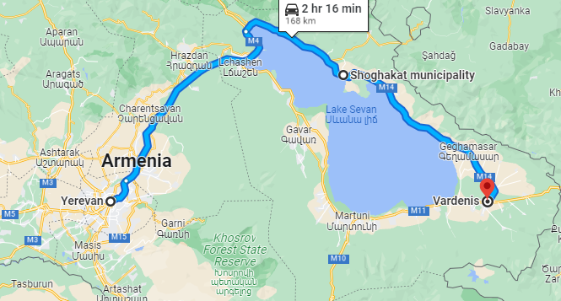

9am | Depart Embassy for Shoghakat, Gegharkunik
10:30am-12pm | Shoghakat, Gegharkunik  Activity site: Local Works COVID-19 Response: The Voice of Communities Activity  IP: "Martuni Women's Community Council" NGO  AOR/COR: Artur Drampyan
12pm-1pm | Lunch
1pm | Depart Shoghakat for Vardenis, Gegharkunik
2pm-3:30pm | Vardenis, Gegharkunik  Activity site: LGRA  IP: ATDF  AOR/COR: Bella Margaryan
3:30pm | Depart Vardenis for Dilijan  Depart Vardenis for Yerevan for those who are not staying overnight
5:30pm | Arrive in Dilijan, hotel check-in (hotel TBD)
7pm | Group dinner

GROUP 2
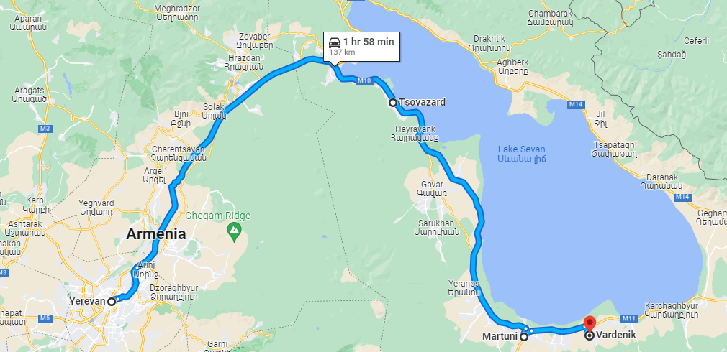

9am | Depart Embassy for Tsovazard, Gegharkunik
10:15am-11:45am | Tsovazard, Gegharkunik  Activity site: RED NEO  IP: CARD  AOR/COR: Simon Sargsyan
11:45 | Dapart Tsovazard for Martuni, Gegharkunik
12pm-1pm | Lunch
1:30pm-3pm | Martuni, Gegharkunik  Activity site: CLASS  IP: WVA  AOR/COR: Ani Manukyan
3pm | Depart Martuni for Vardenik, Gegharkunik
3:30pm-5pm | Vardenik, Gegharkunik  Activity site: AgriCamp  IP: ICARE  AOR/COR: Simon Sargsyan
5pm | Depart Vardenik for Dilijan
6:30pm | Arrive in Dilijan, hotel check-in (hotel TBD)
7pm | Group dinner

DAY 2
GROUP 1
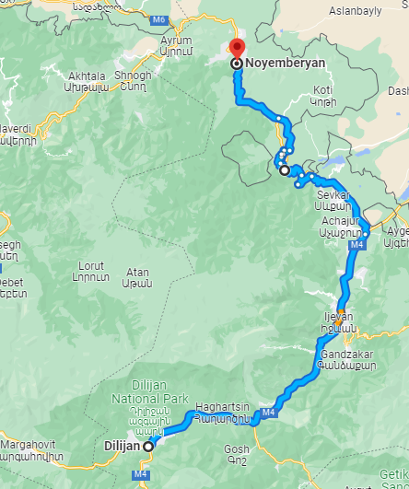

9:00am | Depart Dilijan for Haghartsin, Tavush
9:15-10:45am | Haghartsin, Tavush  Activity site: LGRA  IP: ATDF  AOR/COR: Bella Margaryan
12pm-1pm | Lunch in Noyemberyan
1pm-2:30pm | Noyemberyan, Tavush  Activity site: LGRA  IP: ATDF  AOR/COR: Bella Margaryan
2:30pm | Depart Noyemberyan for Yenokavan, Tavush
3:30pm | Arrive in Yenokavan, hotel check-in (hotel TBD)
Evening: GROUP 1 works on debrief slides for Day 3

GROUP 2
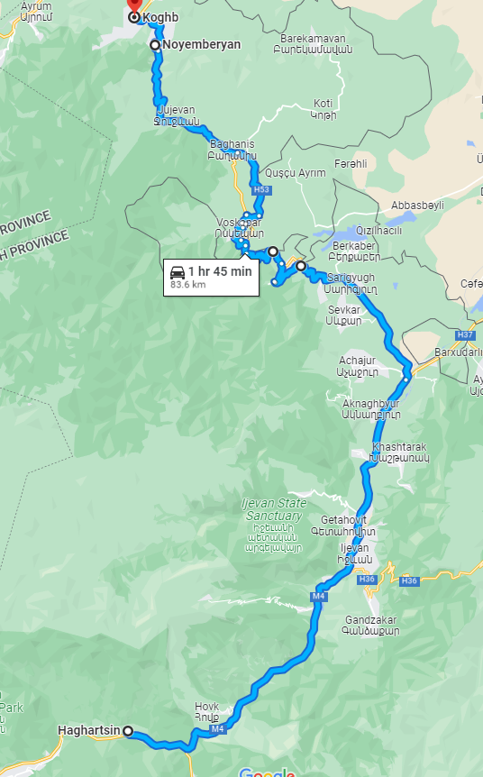

9:00am-10:30am | Dilijan, Tavush  Activity Site: DATA (YCCD)  IP: EPF  AOR/COR: Lusine Hakobyan (alt: Astghik Grigoryan)
10:30am | Depart Dilijan for Noyemberyan, Tavush
10:30am | Depart Dilijan for Noyemberyan, Tavush
12pm-1pm | Lunch in Noyemberyan with GROUP 1
1pm-2:30pm | Noyemberyan, Tavush  Activity site: CLASS  IP: WVA  AOR/COR: Ani Manukyan
2:30pm | Depart Noyemberyan for Koghb, Tavush
2:40-4pm | Koghb, Tavush  Activity site: RED NEO  IP: CARD  AOR/COR: Simon Sargsyan
4pm | Depart Koghb for Yenokavan, Tavush
5:30 pm | Arrive in Yenokavan, hotel check-in (hotel TBD)
Evening: GROUP 2 works on debrief slides for Day 3

DAY 3
GROUP 1 and 2
9:00am-10:30am | Yenokavan, Tavush  Activity site: RED NEO  IP: CARD  AOR/COR: Simon Sargsyan
10:30am-1pm | Plenary in Yenokavan (Berkri)  - WHAT? Short presentations using slide decks from each team to plenary.  - SO WHAT? Facilitated activity to generate ideas for action based on what we’ve learned?  - NOW WHAT? Facilitated exercise to prioritize ideas from the previous round by expected impact/feasibility and identify who would be responsible for taking action?  - NEXT STEPS: Expectation Setting - USAID will consider these recommended actions along with learning from other (conventional) PRs, and commit to communicating decisions back to other participants, as well as developing joint action plans with them.
1am-2pm | Lunch at Berkri
2pm | Depart for Yerevan

