INTRODUCTION

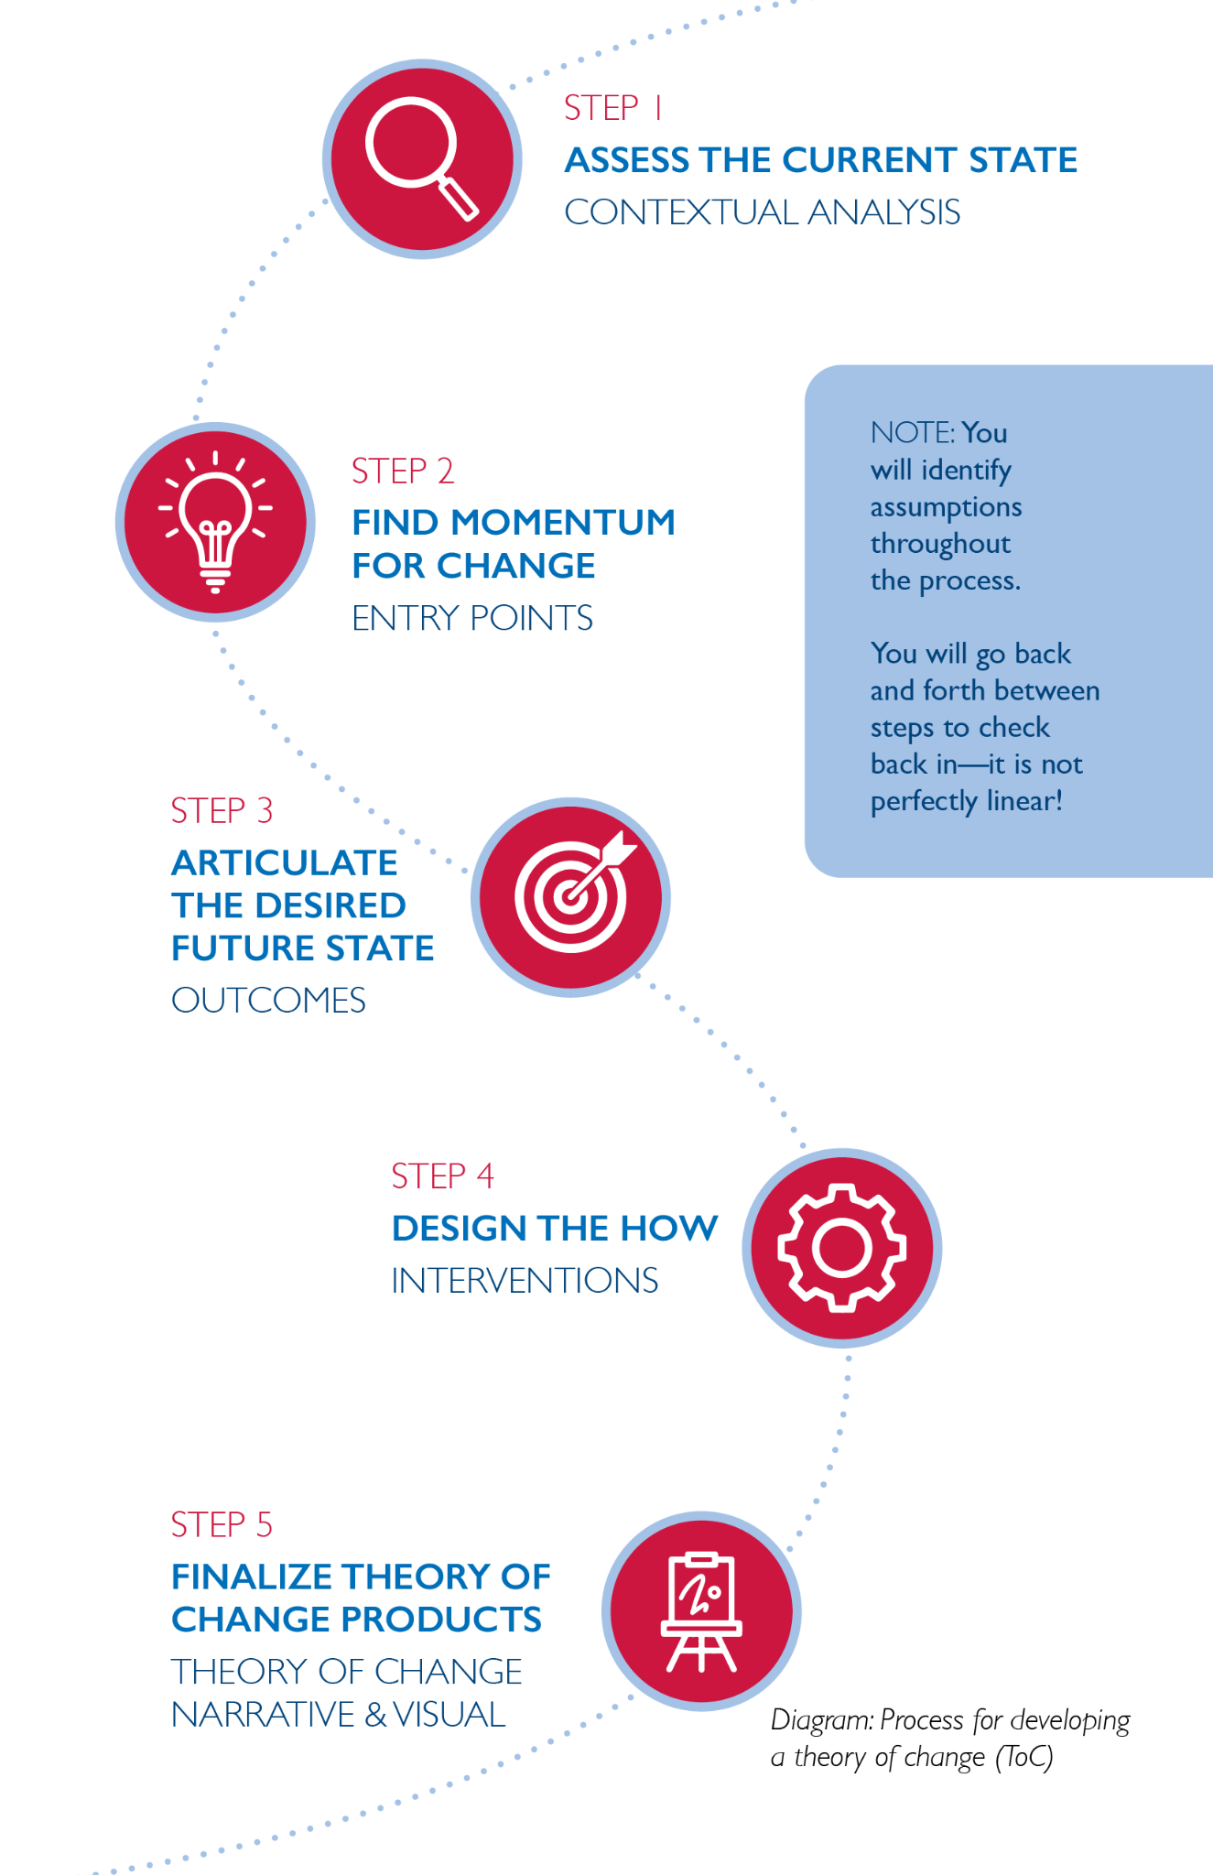

Figure 1: Process for developing a Theory of Change (ToC)

This workbook was originally created for the USAID/Vietnam theory of change clinics for implementing partners, and has been refined through several rounds of use and feedback from USAID/Vietnam and partners. It can be used by design and start-up teams to develop or strengthen their theories of change with local stakeholders.
This theory of change process helps users determine the four key elements of a strong theory of change:
- Outcomes: What is the change we are trying to achieve?
- Entry points: Where is there momentum to create that change?
- Interventions: How will we achieve the change?
- Assumptions: Why do we think this will work?
A strong theory of change process leads to stronger theory of change products, which include:
- the theory of change narrative: a 1-3 page description of the context and responses to the questions above and
- a logic model: a visual representation of the theory of change narrative.
Strong theories of change are:

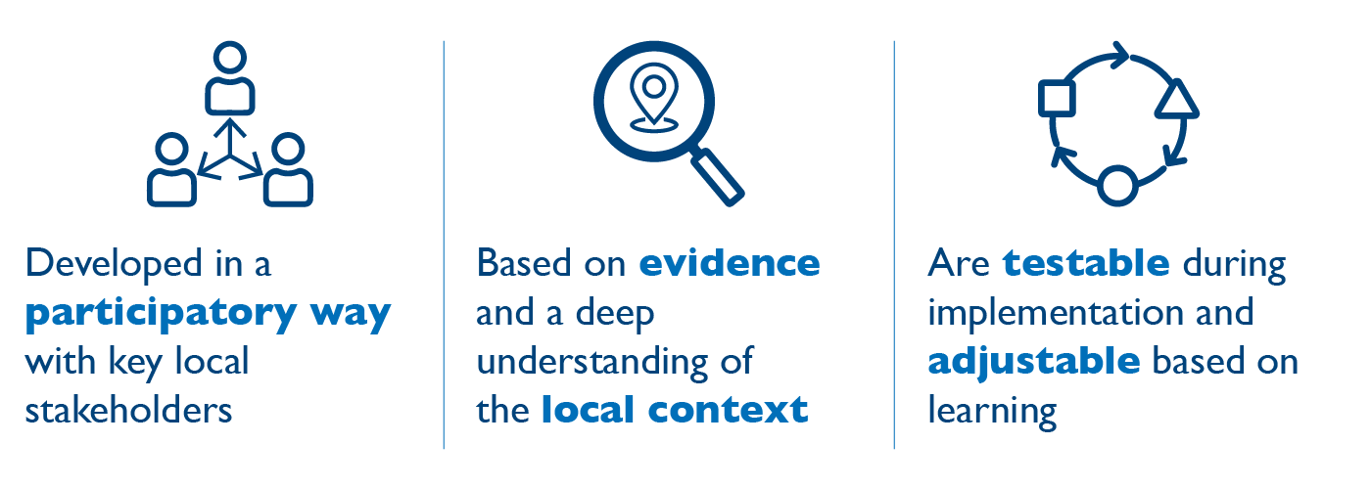

Figure 2: Strong Theories of Change

Teams should invest in a more robust and collaborative theory of change development process because it:
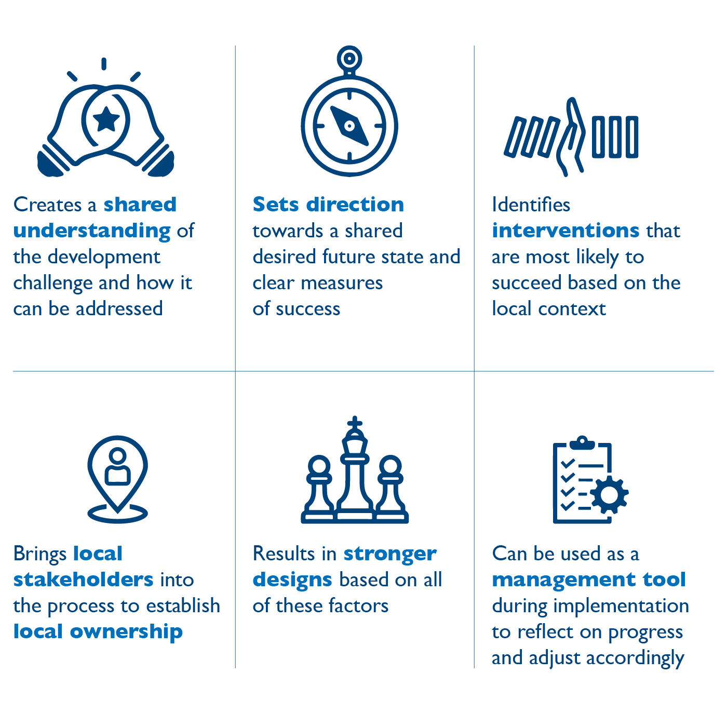

Figure 3: Reasons to Invest in Collaborative ToC
This workbook helps teams accomplish the above whether they are starting the theory of change from scratch or strengthening it during start-up. It is for development practitioners designing new programs or for teams who may have an initial theory of change that they want to strengthen at the start of implementation so it is context-specific, realistic, and representative of a shared vision among staff and local stakeholders.

The process of developing the theory of change is arguably more important than the final products created. It is in that collaboration and conversation with colleagues, local stakeholders, and other partners that the magic happens: we gain and learn from various perspectives on the challenge, the entry points, and anticipated outcomes. These conversations are then synthesized into the products (narrative and logic model), but nothing can replace the experience of those conversations for bringing stakeholders together (in person or virtually) around a shared vision and approach. And ultimately, it is this collaborative, intentional theory of change process that leads to strong theory of change products (the narrative and logic model).
Theory of change development should be highly participatory and, most importantly, include local stakeholders. Working through these steps without local stakeholders risks missing out on important contextual information and developing a theory of change that lacks local buy-in from those most affected.
Before jumping into the process, review these two critical considerations on the ToC process and products:
- On the process: While it is presented as a linear, step-by-step process, you might find yourself jumping back and forth between steps. There is clearly a build-up between steps but don’t be discouraged or surprised if that happens—it is normal!
- On the products: Theory of change products will never be truly final; they are always a work in progress, and because of that, will never be perfect. During implementation, theories of change should be revisited regularly to reflect on whether implementation is unfolding as theorized. For this reason, the theory of change is often the starting point for the Activity’s Monitoring, Evaluation & Learning Plan (AMELP). Following the steps laid out in this workbook helps set you up for effective monitoring, evaluation, learning, and adaptive management practices throughout implementation. We should regularly be asking ourselves:
  - Are the entry points panning out? Are new entry points emerging?
  - Are assumptions holding?
  - Are we on track to achieve outcomes? Are interventions leading to outcomes?
Depending on the answers, we should update our theories of change accordingly so they more accurately reflect the reality of implementation.

STEP 1
ASSESS THE CURRENT STATE: CONTEXTUAL ANALYSIS

WHY? Without this step, your theory of change will not be specific to the context and you will be unable to identify entry points in Step 2.

PRO-TIP: If you get to this stage without having done a contextual analysis (or having worked on the challenge for some time), you may find that you do not know enough about the current state. If that is the case, it is a great time to articulate learning questions (you can borrow from the questions below) that can inform some kind of assessment to better understand the challenge.

PART A: YOUR DEVELOPMENT CHALLENGE
What is the development challenge your activity intends to address? Use the table below to articulate it. Be as specific as possible.

Table 1: Your Development Challenge
What is the development challenge?
Why does it matter? To whom does it matter?

PART B: THE CONTEXT OF YOUR DEVELOPMENT CHALLENGE
Directions: Consider the contextual situation of your development challenge using the guiding questions.

Table 2: Contextual Situation – Current state guiding questions based on USAID's Applied Political Economy Analysis Framework, the 5Rs framework, and gender integration guidance (ADS205)
 | Questions to consider (Note: you do not need to answer each question; they are here as a guidepost to generate ideas & discussion.)
Foundational factors | - What are the factors that are fixed or slow to change (such as geography, natural resource endowments or class structures) that affect the development challenge?  - What are the specific gaps that exist between men, women, or other gendered identities related to the development challenge?
Your responses:

Current outcomes | - What outcome is the local system currently producing? Are there trends (increasing, decreasing) in the outcome over time?  - Do beneficiaries experience differential outcomes?  - Are these differences based on gender, age, ethnicity, disability status, or other differences pertinent to the local context?  - How are the current outcomes produced by the local system viewed by local actors ?  - What other outcomes (positive/negative) do actors note about the local system?  - Does the challenge have a high profile in national or local politics, and why? How does the government view it?  - How adaptive, resilient, or self-sustainable does the local system seem to be?
Your responses:

Rules (formal and informal) | - Are there relevant formal (laws) or informal (norms) rules that affect, enable or bring about the development challenge?  - What are the informal rules of the game (how things really get done) that affect the development challenge?  - What incentives and disincentives are in place that affect how actors behave in the system?  - Are relevant rules enforced? How well? Effectively? Equitably?  - Are actors able to modify the rules and/or incentives that affect them? Are certain groups better able to do that than others?
Your responses:

Actors and their roles | - Who are the main actors interested in addressing the challenge and why? What roles are these actors currently performing?  - Who needs to care more about this challenge, and why? What might influence them?  - Are interests and priorities across these different actors/stakeholders/groups aligned? If not, why not?  - Who are the potential champions and spoilers? Who has influence and in what direction?  - Are some roles being played by different types of actors, such as government, the private sector, or civil society?  - Do men and women play distinctly different, gendered roles?  - Are donors or other third parties playing prominent roles?  - How effectively are actors fulfilling the roles they have taken on? Are there any roles that seem to be absent? Why?
Your responses:

Relationships & power dynamics | - What types of relationships exist between role-players (formal/informal, contractual/hierarchical/reciprocal) described above?  - How strong are these relationships? How valued are these relationships? Are they collaborative? Conflictual?  - Are there relationships identified as missing, weak, unnecessary or illegitimate?  - What are the power dynamics among actors? Consider champions and spoilers, and differences related to gender or social status.  - Are certain groups excluded from decision-making bodies or processes (whether formal or informal)?
Your responses:

Resources | - What resources (financial, technical, etc.) are currently being used by the local system in producing current outcomes?  - What are the sources of those resources? Are they reliable and secure?  - Are there needed resources that are missing or insufficient to address the challenge?  - Are there trends (increasing, decreasing) or patterns (cyclical) in resource inflows?  - Are there trends or patterns in who controls resources and how that affects resource flows?
Your responses:

CONNECTION TO MONITORING, EVALUATION & LEARNING DURING IMPLEMENTATION: As mentioned, ToCs are also helpful management tools during implementation. This step is a learning exercise, and can be revisited throughout implementation to identify any changes in the context that may require adjustments to the theory of change or implementation approaches. Return to this, in particular, when there are significant context shifts that have ripple effects on your programming.

STEP 2
FIND MOMENTUM FOR CHANGE: ENTRY POINTS

WHY? Without this step, you will not have clear entry points, which are critical to determining which interventions are likely to be successful in achieving outcomes. You may also end up working on interventions that are unlikely to succeed (i.e., brick walls described below).

PRO-TIP: If we had to choose which step is most critical to establishing a sensible, context-driven theory of change, it would be this one. Spend as much time here as you need; everything else flows from this step.

PART A: DISCUSSION QUESTIONS
Directions: Based on the contextual analysis above, answer the discussion questions below.

Table 3: Discussion Questions
Where is there momentum for change?
- What, if anything, about the context is changing, creating openings to enable change?
- Are there likely future opportunities to address the challenge? Why? Timing, actors, and openings?
Your responses:

Where are the dynamic areas where change can have a ripple effect (a ripple effect occurs when change in one area can spark change in other areas)?
Your responses:

Where are there bright spots that can be built upon (bright spots are areas of current success or positive change)?
Your responses:

Where is the system frozen / stuck?
Your responses:

PART B: IDENTIFY OPEN DOORS, LOCKED DOORS, AND BRICK WALLS
Directions: Based on the discussion in Part A, determine your entry points (open and locked doors) and what is not an entry point (brick walls) as described below. In the subsequent steps, focus on those open and locked doors, and avoid the brick walls.

Table 4: Determine Entry Points
Type | Definition | Your responses: Where do you see open doors, locked doors, and brick walls in relation to your development challenge?
Open doors | Opportunities for change or reform in which a broad constituency already exists that requires only a catalyst to achieve progress.  If you have an open door, go for it!
Locked doors | Opportunities for which change is possible, but will require concerted effort to open them.  To unlock the door, you need the right key.
Brick walls | Certain reforms or changes are likely to face such entrenched resistance that it may be a misallocation of resources, political capital and time to attempt to shift them.  Avoid, stop, turn around.

PART C: CHECKING IN ON ASSUMPTIONS AND KNOWLEDGE GAPS
Directions: Answer the discussion questions below to help inform your theory of change (assumptions) and any additional information you need to gather before or during implementation.

Table 5: Assumptions and Knowledge Gaps
What assumptions are you making about the context and your entry points?
Your responses:

What information about the current state do we still need? What are our gaps in knowledge that are essential to fill?
Your responses:

CONNECTION TO MONITORING, EVALUATION & LEARNING DURING IMPLEMENTATION: As mentioned, ToCs are also helpful management tools during implementation. This step is a learning exercise, and can be revisited throughout implementation to identify any changes in entry points that may require adjustments to the theory of change or implementation approaches. Return to this, in particular, when there are significant context shifts that have ripple effects on your programming.

STEP 3
ARTICULATE THE DESIRED FUTURE STATE: OUTCOMES

WHY? Knowing where you are headed is essential for a strong theory of change. It brings participants together around a shared North Star.

PRO-TIPS:
- Focus on outcomes that are possible given the local context and the entry points identified.
- Very important: you may need to return to Step 2, Part B after thinking through this step. Now that you have your outcomes, you may need to confirm entry points. There is a back and forth between steps 2 and 3 especially; this is normal.
- Make sure you are articulating outcomes (real changes in the status quo), not outputs (see this resource for a detailed discussion on the distinction between outputs, outcomes, and impact).
- In some cases, participants will know they will work on the development challenge for many years to come after the period of performance. If this is the case, you can think about this question in stages - you may have a 10 year vision but a five year program; simply make sure the time matches the resources you have and be clear about expected outcomes for this specific program.

PART A: WHAT TYPE OF IMPACT IS POSSIBLE?
Directions: Review the six models for impact. Determine what type of impact is possible given your discussions in the previous steps. This will help you determine how you articulate your outcomes. Note that you may have multiple types of impact depending on which aspect of the activity or project you are focused on, but try to consider overall impact. And, yes, as we have been asked several times, participants can come up with their own impact model as long as it makes sense.
Type of impact (see options here) | Rationale (Why did you choose this one?)
Your responses: | Your responses:

PART B: DETERMINE REALISTIC OUTCOMES BASED ON ENTRY POINTS
Directions: Identify realistic outcomes based on the entry points you have identified using the discussion questions as a guide.
Table: Desired future state guiding questions based on USAID's Applied Political Economy Analysis Framework, 5Rs framework, and gender integration guidance.
Questions to consider based on identified entry points
(Note: you do not need to answer each question; they are here as a guidepost to generate ideas & discussion.)
Overall outcomes | - What are the target outcomes around which you can define possible success based on the entry points identified? Are the target outcomes valued by local actors? Which ones?  - What other positive outcomes can the future system produce? What negative outcomes can the future system stop producing?  - What unintended outcomes may emerge from the future system?
Your responses:

System level change | To enable the local system to function well, and based on the entry points identified:  - What rules (informal and formal) can realistically be changed?  - What incentives can realistically be changed?  - What changes in relationships between actors can be realistically achieved?  - What changes in power dynamics and gender relations between actors can be realistically achieved?  - What roles can be realistically added, subtracted, or changed? Consider also gender roles here.  - What barriers can realistically be removed or reduced to achieve equitable outcomes among target groups?  - What changes in resource flows or control of resources can be realistically achieved?  - What opportunities can realistically be created for previously under-represented or under-served groups?
Your responses:

Individual change | To enable the local system to function well, and based on the entry points identified:  - What changes in knowledge, skills, mindsets, or mental models can realistically be achieved?  - What changes in behavior can be realistically achieved?
Your responses:

PART C: REVIEW OUTCOMES IDENTIFIED
Directions: Review the outcomes you have brainstormed using the discussion questions below; then, make adjustments as needed above.
- Are these the highest level outcomes we can hope to achieve or contribute to within the local system during the program period?
- Are they outcomes (changes in the local system) and not outputs (project deliverables)?
- Are there SMART outcomes: specific, measurable, achievable, realistic, and time-bound? Why do you think they are likely to be achieved? Are there any outcomes that are unrealistic given the local context or the amount of time and money available? (Note the connection here to monitoring during implementation.)
- How are the outcomes related to each other? Do certain outcomes need to happen before others? (Note the connection here to assumptions.)
- Can the program be solely responsible for these outcomes? Or do other actors outside of the program need to contribute to achieve these outcomes? (Note the connection here to assumptions.)

CONNECTION TO MONITORING, EVALUATION & LEARNING DURING IMPLEMENTATION: As mentioned, ToCs are also helpful management tools during implementation. This step will set you up for more meaningful and effective monitoring of key outcomes during implementation.

STEP 4
DESIGN THE HOW: INTERVENTIONS

WHY? Participants are starting to build a coherent narrative in this step, leading directly into Step 5 (ToC products). This step also helps participants integrate and synthesize all they have talked about in previous steps.

PRO-TIP: It is important throughout, but particularly here, to identify your assumptions about how change will happen. These assumptions may start to become most obvious in this step.

PART A: BRAINSTORM INTERVENTIONS & ASSUMPTIONS
Directions: Brainstorm interventions based on your desired future state and entry points using the tables and discussion questions embedded below. The first three boxes (current state, desired future state, and entry points) are discussions you have already had that simply need to be summarized; boxes 4 and 5 are new discussions in this step. Start with (1) desired future state (which priority outcomes are you ultimately working toward?) → then move to the (2) current state vis-a-vis those outcomes → then considering your (3) entry points → identify (4) interventions that bridge the gap between the current state and the desired future state and finally → (5) assumptions that we are making based on how we think change might happen. If you have distinctly different outcomes under your program, we recommend having one table per outcome.

Table 1: Brainstorming interventions and assumptions based on previous steps
 | 2  Current state | 1  Desired future state
 | Sentence summary based on Step 1: Articulate the current state vis-a-vis the desired future state (what is the challenge like now?) | Sentence summary from Step 3: Articulate the priority outcomes (If you have distinctly different outcomes under your program, we recommend having one of these tables per outcome.)
3  Entry points | Summarize from Step 2, Part B: Articulate the entry points that will be the jumping off point for moving from the current state to the desired future state
4  Interventions | Based on the identified entry points:  - What set of interventions could realistically bridge the gap between the current state and desired future state?  - What could motivate actors to behave differently in the local system?  - How can we support these changes? Who else needs to do what in order to realize the desired future state?  - Is there potential for collective action among stakeholders that USAID could catalyze? What could this look like and achieve? Who needs to come together? How?  Intervention 1:  Intervention 2:  Etc.:
5  Assumptions about how change could happen | - Why do we think this will work?  - What assumptions are we making about the local context or about how change could happen?  - Note your confidence and risk levels for your assumptions (low, medium, high). Assumptions with low confidence and / or high risk (if it does not hold, the program is in jeopardy) may influence whether you prioritize an intervention and/or should be prioritized for tracking during implementation.  Assumption 1: xx (low confidence, high risk)  Assumption 2: xx (medium confidence, low risk)  Assumption 3: xx (high confidence, medium risk)

PART B: PRIORITIZE INTERVENTIONS
Directions: Consider the following reflection questions and update your thinking above, as necessary. You may not need to do this step if you have sufficient resources for all the intervention ideas above.
- Which interventions are most important? You can use something like the resource-impact matrix or action-priority matrix to help you prioritize. Consider prioritizing interventions that are high impact and low resources or high impact and high resources (assuming resources are available). You can also use assumptions to help prioritize. Interventions with faulty or low confidence / high-risk assumptions may be deprioritized.
- Are there any considerations for sequencing of interventions to achieve the desired future state / outcomes? What needs to happen first?
CONNECTION TO MONITORING, EVALUATION & LEARNING DURING IMPLEMENTATION: As mentioned, ToCs are also helpful management tools. To set your team up for using the ToC during implementation, we recommend after this step to:
- Determine which of your assumptions are low, medium, or high confidence. Later you will want to determine how you will track assumptions, particularly those that are low confidence and/or high risk through monitoring and learning activities.
- You may also find here that you still have significant knowledge gaps that make it difficult for you to feel confident in your theory of change. If that is the case, you can use this as an opportunity to articulate learning questions that will resolve those knowledge gaps and strengthen implementation.

STEP 5
DEVELOP THEORY OF CHANGE PRODUCTS: NARRATIVE & VISUAL

WHY? This is the synthesis of your thinking thus far that you return to throughout implementation. It articulates the what, why, and how of your program!

PRO-TIPS:
- Do this step as quickly as possible after any facilitated sessions or dialogues following the steps above. You don’t want to forget all that great thinking and fail to include it in your theory of change narrative or visualization!
- Each team is different—some may want to start with writing, while others may want to start with the visual. Either way is fine!
- All steps of this process are participatory, but this may be where participants break as a group and identify a skilled writer and/or visual thinker to assemble. It is still participatory in that other stakeholders should review the draft, but it is also often inefficient to write a theory of change narrative or visualize it by committee. Consider who should do these initial drafts, who should review, and who ultimately approves your ToC narrative and visualization (known as the logic model).

GUIDANCE: Rather than providing step-by-step instructions here, we have simply described what should be included in both the ToC narrative and logic model. Please refer to these examples of strong theories of change.

Table 2: Developing ToC Narrative and Logic Model
 | ToC Narrative | Logic Model
What? | 1-3 page write-up of:  - Contextual analysis: description of the current state of the development challenge and what is holding the challenge in place  - Entry points within the local context that enable change  - Intended changes / outcomes that described the desired future state  - Interventions that bridge the gap between the current state and the desired future state  - Assumptions that make explicit the beliefs about the context that make it likely for the theory of change to hold | Visual representation of the ToC narrative; no required format.
Why? | - Know where the activity or project is headed  - And how we think it will get there  - Helps make sure your approach is realistic and achievable based on the context | - Makes communication and engagement with local stakeholders easier  - Easy reference point to review and reflect on

Make sure your ToC narrative answers the following questions:
- Context: What are the important elements of your analysis of the current situation / system to highlight in the ToC narrative? What is holding the challenge in place?
- Entry points: Where is there momentum to create that change? Identify your prioritized entry points and build the rest of the narrative from the entry points.
- Outcomes: What is the change we are trying to achieve? Identify 2-3 key outcomes (not outputs) that you will track over the life of the Activity to know if your Activity is contributing to change.
- Interventions: How will we achieve the change? Do your proposed interventions take advantage of the entry points? Why are they likely to actually work?
- Assumptions: Why do we think this will work? What are your assumptions (context and programmatic)? Are your assumptions reasonable?
Make sure your visualization (known as the logic model) clearly identifies the entry points, outcomes, interventions, and assumptions. The visual will always be a shorthand and will typically not be able to capture the nuance or complexity of the narrative. It is meant to take a complex situation and visualize it as clearly and simply as possible for users to be able to understand quickly what the program does and how it thinks change can be achieved.

ANNEX 1
DEFINITIONS
ASSUMPTIONS | The stated conditions and/or critical events outside the control of the activity that must be in place for outcomes to be achieved. Assumptions form part of the complete theory of change regarding the conditions under which change is envisioned to occur. They may be listed within the logic model itself, or to the side. (ADS201)
CONTEXT (OR SYSTEM) OR CURRENT STATE | In which the development challenge is situated. This includes root causes or drivers underlying the development challenge, as well as circumstances or conditions in the operating context that may affect intended Activity’s outcomes and are likely to change.
DESIRED FUTURE STATE | What stakeholders hope the situation will look like once the development challenge is addressed; described by SMART outcome statements.
ENTRY POINT | Momentum concerning the development challenge that could be leveraged to commence or expand an intervention.
INDICATORS | They are used to measure the most important expected Activity outcomes and assumptions. Indicators can be listed alongside the outcomes or assumptions that they represent within the logic model. At a minimum, they must be captured in the Activity Monitoring, Evaluation and Learning (MEL) Plan. (ADS201)
INTERVENTIONS | What the Activity intends to implement to directly or indirectly influence a set of outcomes
LOGIC MODEL | A visual or graphic depiction that is a snapshot of a more complete (narrative) ToC. (ADS201)
OUTCOMES | The conditions of people, systems, or institutions that indicate progress or lack of progress toward achievement of program goals. They are any result higher than an output to which a given output contributes, but for which it might not be solely responsible. (ADS201)
OUTPUTS | The tangible, immediate, and intended products or consequences of an activity within USAID’s control or influence; the direct result of inputs. (ADS201)
RESULTS | They are significant and intended changes in a development condition that affect people, systems, or institutions. They are outputs and/or outcomes and are achieved as a result of the Activity’s interventions. (ADS201)
THEORY OF CHANGE | A narrative description, usually accompanied by a graphic or visual depiction (the logic model), that describes how and why a purpose or outcome is expected to be achieved in a particular context. It is focused in particular on mapping out or “filling in” what has been described as the “missing middle” between what a program or change initiative does (its activities or interventions) and how these lead to desired goals being achieved. (ADS201)

ANNEX 2
SAMPLES

Follow the link for Theory of Change narratives and associated logic models.

ANNEX 1
DEFINITIONS

ASSUMPTIONS | The stated conditions and/or critical events outside the control of the activity that must be in place for outcomes to be achieved. Assumptions form part of the complete theory of change regarding the conditions under which change is envisioned to occur. They may be listed within the logic model itself, or to the side. (ADS201)

The process outlined here is inspired by systems thinking, and you will find overlaps and similarities to other approaches like problem-driven iterative adaptation and context-driven adaptation. The process also borrows from tools such as USAID’s 5Rs framework and USAID’s applied political economy analysis framework. Ultimately, it is aligned with Collaborating, Learning & Adapting (CLA), USAID’s approach to strategic collaboration, organizational learning, and adaptive management. For questions on this workbook, contact the author, Monalisa Salib.
Note that USAID design teams may not include interventions in their theories of change in solicitations or design documents; instead, the interventions may be left to the offerors to outline or further detail during implementation.
Similar terms include issue, problem, target result.
Note that this workbook assumes users already have a clear development challenge or problem that they are working through. If you want to spend more time on problem articulation, consider using this resource (sections 1 & 2 specifically).
These gaps should consider the Domains of Gender Analysis outlined in ADS 205.3.2 - (1) laws, policies, regulations, and institutional practices that influence the context in which men and women act and make decisions; (2) cultural norms and beliefs; (3) gender roles, responsibilities, and time use; (4) access to and control over resources; (5) patterns of power and decision-making

